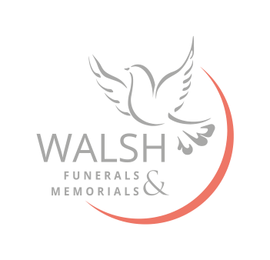

Below are the costs for the local Crematoriums that we regularly attend. These are all within a 30-minute journey, travelling at cortege speed, from our Bloxwich, West Bromwich and Great Wyrley funeral homes.

Mercia Forest Crematorium
Direct cremation service £525
Standard Fee £925/£1025
Streetly Crematorium
Direct cremation service £410
Early Morning, short service £450
Standard Fee £952
Bushbury Crematorium
Standard Fee £940
Sandwell Valley Crematorium
Direct cremation service - weekday £685
Standard Fee- weekday £904
Standard Fee- weekend £1,040
Cannock Chase Crematorium
Direct Cremation service- Sunrise Services £395
Early morning service- Simple Service £550
Shorter service before Midday- Serenity Services £770
Standard Fee - Celebration of Life Service £940
Gornal Wood Crematorium
Standard Fee £995

